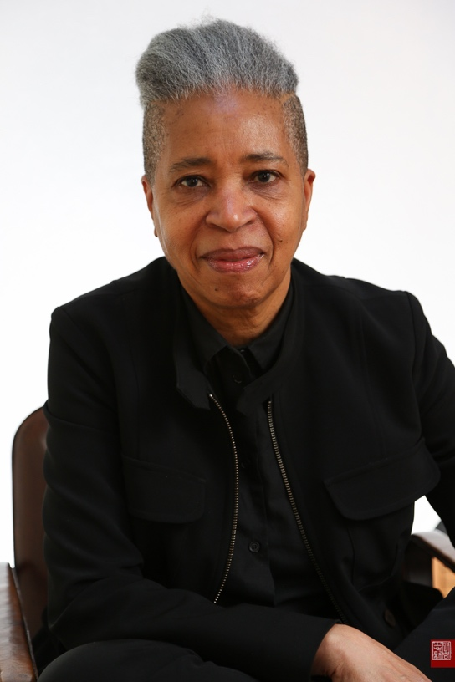
JHI Distinguished Visiting Fellow for 2021

Dionne Brand

A Short Entry on Time –
Capitalism, Time, Blackness and Writing

Dionne Brand is a renowned poet, novelist, and essayist. Her writing is notable for the beauty of its language, and for its intense political engagement. Her work includes nine volumes of poetry, five books of fiction and two non-fiction works. She was the Poet Laureate of the City of Toronto 2009-2012.

Dionne Brand became prominent first as an award-winning poet, winning the Griffin Poetry Prize for her volume Ossuaries, the Governor General’s Literary Award and the Trillium Book Prize for her volume Land to Light On. She’s garnered nominations for the Governor General’s Literary Award for the poetry volumes No Language Is Neutral and Inventory respectively, the latter also nominated for the Trillium and the Pat Lowther. She has won the Pat Lowther Award for poetry for her volume thirsty also nominated for the Griffin Poetry Prize and the city of Toronto Book Award. Her 2018 volume, The Blue Clerk, was nominated for the Governor General’s Literary Award for poetry and the Griffin Poetry Prize and won the Trillium Book Prize.

Brand has also achieved great distinction and acclaim in fiction and non-fiction. Her most recent novel, Theory won the Toronto Book Award 2019 and the BOCAS fiction prize. Her novel, Love Enough was nominated in 2015 for the Trillium Book Award. Her fiction includes the novel In Another Place, Not Here, a New York Times notable book in 1998, and At the Full and Change of the Moon, a Los Angeles Times Notable Book of the Year in 1999. Her critically acclaimed novel, What We All Long For, which won the Toronto Book Award, offers an indelible portrait of the city of Toronto; it has been translated into Italian, French and German. Her non-fiction includes Bread Out Of Stone, and A Map to the Door of No Return, which has been widely taken up by scholars of Black Diaspora. Her 2019 Kreisel Lecture, An Autobiography of the Autobiography of Reading was published in March 2020. In this work she takes up the colonial structures of reading.

Dionne Brand has published nineteen books, contributed to seventeen anthologies and written dozens of essays and articles. She has also been involved in the making of several documentary films. She was a Distinguished Visiting Professor at St. Lawrence University in New York and has taught literature and creative writing at universities in both British Columbia and Ontario. She has also held the Ruth Wynn Woodward Chair in Women’s Studies at Simon Fraser University. She holds several Honorary Doctorates - Wilfred Laurier University, University of Windsor, Simon Fraser University, The University of Toronto, York University and Thornloe/Laurentian University. She lives in Toronto and is Professor in the School of English and Theatre Studies at the University of Guelph. She is a member of the Order of Canada.

Wednesday 3 March, 3:30 p.m.

