Happy 2020, everyone!

First, we are thrilled to formally announce our new name:

Resource Centre for Public Sociology

The first Resource Centre for Public Sociology (RCPS, formerly QRRC) panel
discussion takes place

Tuesday, January 21, 2020
Ross N141, 11:30 – 2 p.m.

Light lunch will be provided.

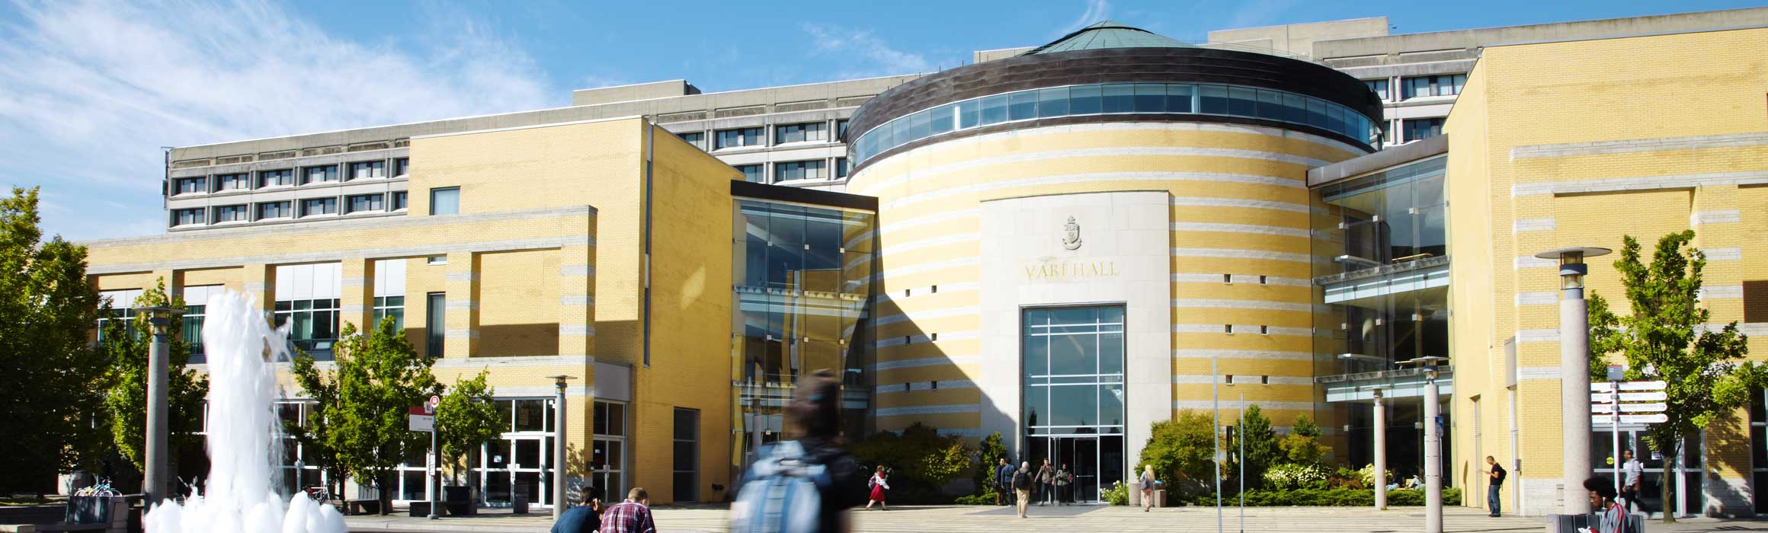

Getting Public About Public Education

Please join us as we welcome
Karen Robson (McMaster), Gillian Parekh (York), and
Robert S. Brown (TDSB).

In this talk, the panelists will describe the techniques they have used to communicate their findings in education research to the wider community. All three panelists have examined data from the Toronto District School Board which has led to discoveries of various inequities around the characteristics of social class, self-identified race, and special education needs. All panelists have experience (good and bad) communicating with the wider community of stakeholders and the media about their findings.

Each panelist brings a unique perspective, all having had different research trajectories: Robson as a sociologist working within the university but in collaboration with the TDSB, Parekh having worked in both academia (York) and the school board, and Brown working almost exclusively as a researcher at the TDSB but with adjunct status at York. We will talk about the techniques of communicating research to the wider community and the sorts of experiences we have had as this relates to debates within the Toronto education system.

Speakers

Karen Robson is the Ontario Research Chair in Educational Achievement and At-Risk Youth and Associate Professor of Sociology at McMaster University. She has led many projects on examining the predictors of post-secondary access and has completed many research contracts with branches of the Ontario government.

Gillian Parekh is an Assistant Professor and Canada Research Chair (Tier 2) in the Faculty of Education at York University. With a doctorate in Critical Disability Studies, Gillian has conducted extensive research with the Toronto District School Board in the areas of structural equity, special education, and academic streaming. Her work explores how schools construct and respond to disability as well as organize students across programs.

Robert S Brown has worked in applied research for over thirty-five years, in media research, market research, and education research, retiring from the Toronto District School Board (TDSB) in August. An adjunct professor at York, he has authored or co-authored academic publications in several fields including education, psychology, sociology, and medicine.

