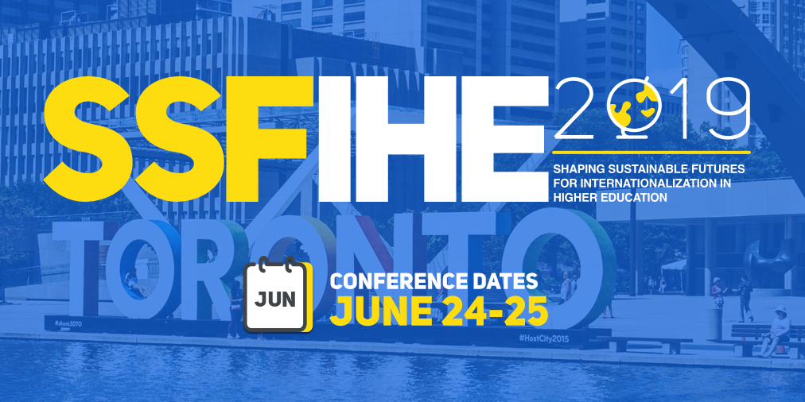
Shaping Sustainable Futures for Internationalization in Higher Education (SSFIHE 2019) is one month away!
Join academics, practitioners, policy makers and students at this exciting two day conference in Toronto on June 24-25 as we engage in discussions, workshops and presentations that take stock of internationalization in higher education as it is currently evolving around the globe, and consider ways in which it could be shaped sustainably into the future.
A detailed overview of the conference program is available on the SSFIHE 2019 website: https://www.ssfihe2019.ca/program-outline.
On the website you’ll find a full list including abstracts for each of our 30+ sessions taking place during SSFIHE 2019.
In addition to these exciting sessions, we have three exceptional keynotes: Jane Knight, Ka Ho Mok and Chika Trevor Sehoole.
The registration fee is C$175, or just C$60 for current students (full-time and part-time) and post-doctoral researchers. The fee also includes refreshments and lunch on both days.
Register now to secure your place at SSFIHE 2019!

